Applying Ontology-Based Knowledge Representation in Disaster Management System

Abstract— The computational complexity and interoperability problems that come with disaster control operations are often too much for traditional database systems to handle. in order to show how ontological modeling improves data representation, reasoning, and decision-making, this work addresses the implementation of ontology for a disaster management system (DMS). to represent disaster-related entities, such as disaster types, impacted regions, emergency resources, and relief companies, as well as their interrelationships, a established ontology is created using Protégé. a methodical procedure of definition, development, regulation, implementation, and evaluation is observed by the method. The findings show how the ontology may enhance situational focus in real time, reduce down on duplicate information, and help with smart decision-making in disaster response conditions. a vital evaluation of the characteristic of ontology information management in DMS and its wider impact in artificial intelligence applications is offered in the study's end.
Keywords— ontology, disaster management system, knowledge representation, Protégé, emergency response, reasoning, Artificial Intelligence

Introduction
In a generation marked by a increasing frequency and depth of natural and man-made disasters, efficient disaster control has end up a vital issue of national and global safety. The growing complexity of disaster response, from aid allocation and personnel coordination to damage assessment and communication with affected populations, has exposed the constraints of traditional database systems that usually manage data without capturing its semantic meaning [1]. Ontology, a core idea in artificial Intelligence (AI), gives a solution by offering a structured and semantically rich illustration of knowledge inside a specific domain [2]. in the context of a disaster management system (DMS), a ontology enables the definition of entities such as forms of disasters, geographical places, available resources, and responsible groups, while also modeling their interrelationships and constraints [3]. This semantic method not only helps interoperability and information sharing among disparate emergency control systems but also enhances reasoning abilities, allowing systems to deduce new information and assist smart decision-making during crises [4]. This paper gives a investigative study into the improvement and application of a ontology-based disaster control system using Protégé. The study outlines the method employed to construct the ontology, analyzes its capability in addressing real-world disaster control challenges, and severely discusses its capacity advantages and limitations. by demonstrating how ontology can enhance information control in DMS, this studies also contributes to the wider information of ontology’s role in AI applications for public safety and emergency response [5].

Case Study: Disaster Management System

Problem Context

The primary workflow of a disaster control system is the coordination of data and resources to mitigate the impact of, prepare for, respond to, and recover from failures. current disaster scenarios contain a mess of stakeholders, such as government groups, non-governmental groups (NGOs), and the general public, all of whom must synchronize their efforts in real-time. challenges such as inaccurate damage reports, inefficient aid allocation, delayed reaction times, and a lack of interoperability across unique data systems often restrict the effectiveness of disaster control operations [7]. traditional relational databases and control software usually save data but fail to seize the semantic meaning and interrelationships vital for advanced reasoning and smart decision-making in the chaotic and rapidly evolving environment of a disaster [1].

Justification for Ontology Based Approch

A ontology provides a semantically rich framework to model disaster-related entities and their relationships, enabling more powerful information representation and reasoning than traditional methods [2]. by defining classes such as disaster, AffectedArea, EmergencyResource, ReliefAgency, and AffectedPopulation, along with their properties and constraints, a ontology-based DMS supports: semantic interoperability, facilitating data integration from heterogeneous resources like weather reports, sensor networks, and social media feeds [5]; reasoning abilities, allowing for automated inference, such as predicting the potential impact of a disaster or identifying the most suitable evacuation routes [7]; reuse, making the model adaptable to different forms of failures and scalable as the scenario evolves [3]; and advanced decision-making, offering real-time insights for aid mobilization, personnel deployment, and communication techniques [4]. therefore, a ontology gives a based, reusable, and smart answer to overcome the complexity of modern disaster control, surpassing the competencies of traditional data management strategies.

Prior Knowledge Required for problem scenerio
To effectively model a Disaster Management System (DMS) using an ontology, it is essential to identify the core components of disaster management operations, which are defined as classes, object properties, and data properties within the ontology [2]. These key components serve as the foundational building blocks for the semantic modeling of a disaster scenario.

Core Entities and Relationships

Vital entities include disaster (e.g., earthquake, flood, wildfire), GeographicalLocation (areas affected by the disaster), aid (e.g., medical elements, shelters, emergency cars), agency (e.g., government groups, NGOs), person (such as victims and response personnel), and task (unique moves to be taken during the response) [7]. these entities engage via unique item homes such as hasLocation (disaster → GeographicalLocation), dispatches (agency → aid), assignedTo (person → task), and impacts (disaster → person), thereby enriching the ontology with relational semantics [6]. moreover, disaster response operations adhere to various constraints and protocols, such as aid compatibility (e.g., sure medical elements for unique injuries), personnel qualifications, and communique hierarchies. these rules can be encoded in the ontology to allow automated reasoning and validation of response plans [8]. Technical issues also play a vital role in constructing a strong DMS ontology. these include modeling the dynamic nature of a disaster to help temporal reasoning, integrating information from various resources such as remote sensing and social media for a comprehensive situational image, and aligning the ontology design with the overarching goals of minimizing casualties, shielding assets, and ensuring a fast recovery [7]. Ontologies allow for the formal capture and reuse of information across unique disaster sorts and stages, helping interoperability and dynamic querying inside DMS [2]. ultimately, the semantic richness and flexibility supplied by ontology-based structures role them as powerful tools for designing smart and adaptable disaster control architectures [5].

Methodology And Implementation
To expand the ontology for the disaster management system (DMS), we adopted the well-set up 7-step method by Noy and McGuinness [3]. This method gives a based and iterative method for building ontologies, ensuring each conceptual readability and semantic consistency. it is mainly suitable for area-unique knowledge modeling where reasoning, reusability, and extensibility are vital [2].
Step 1: Decide the area and Scope the chosen domain for our ontology improvement is disaster control systems. The scope encompasses key disaster control sports such as disaster event modeling, aid allocation, damage evaluation, response group coordination, and data dissemination to the public. The primary goal is to facilitate wise reasoning over disaster impact, aid availability, and usual response effort optimization. by semantically modeling these factors, the ontology helps automated decision-making in dynamic and high-stakes disaster environments [7].
Step 2: Remember Reuse before designing the ontology from scratch, current ontologies were explored for ability reuse. Ontologies such as the friend of a friend (FOAF) vocabulary for describing people and their relationships, and the GeoSPARQL trendy for representing geospatial data were tested. but, due to the unique operational needs and area-unique intricacies of disaster control, a custom ontology was deemed more suitable to seize the unique nuances of disaster sorts, response protocols, and aid control. This method aligns with best practices in ontology improvement, which advise for reuse where viable but also inspire tailored modeling for specialised domains [3].
Step 3: Enumerate vital terms Key terms relevant to the disaster control area were identified via the evaluation of emergency operations plans, after-movement reports, and interviews with issue rely experts. these terms include disaster type, incident severity, evacuation sector, refuge capacity, emergency aid feature, aid fame, and casualty data [7].
Step 4: Define classes and Hierarchies The core of the ontology includes well-defined classes based in hierarchies. for example, the disaster class is subclassed into NaturalDisaster and ManMadeDisaster, that are further broken down into more unique sorts like Earthquake, Flood, ChemicalSpill, and TerroristAttack. in addition, aid is subclassed into HumanResource (e.g., medical personnel, search and rescue teams) and MaterialResource (e.g., medical supplies, heavy equipment). extra primary classes include GeographicalArea, agency, Infrastructure, and InformationSource. these taxonomies allow a semantically rich representation of entities and their contextual relationships [6].
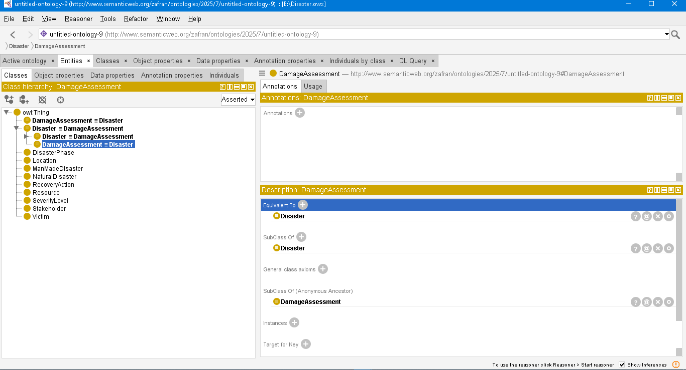
Figure 1: illustrates the basic classes & Hierarchies

Step 5: Define Relationships among classes are modeled using object properties such as occursIn (disaster → GeographicalArea), dispatches (agency → aid), isAssignedTo (HumanResource → task), and isDamagedBy (Infrastructure → disaster). In parallel, data homes such as hasMagnitude, hasCasualtyCount, hasCapacity, hasTimestamp, and hasStatus are defined to represent the attributes of those classes. for example, a disaster example has a hasMagnitude assets, which allows for reasoning about the severity of the event [7].
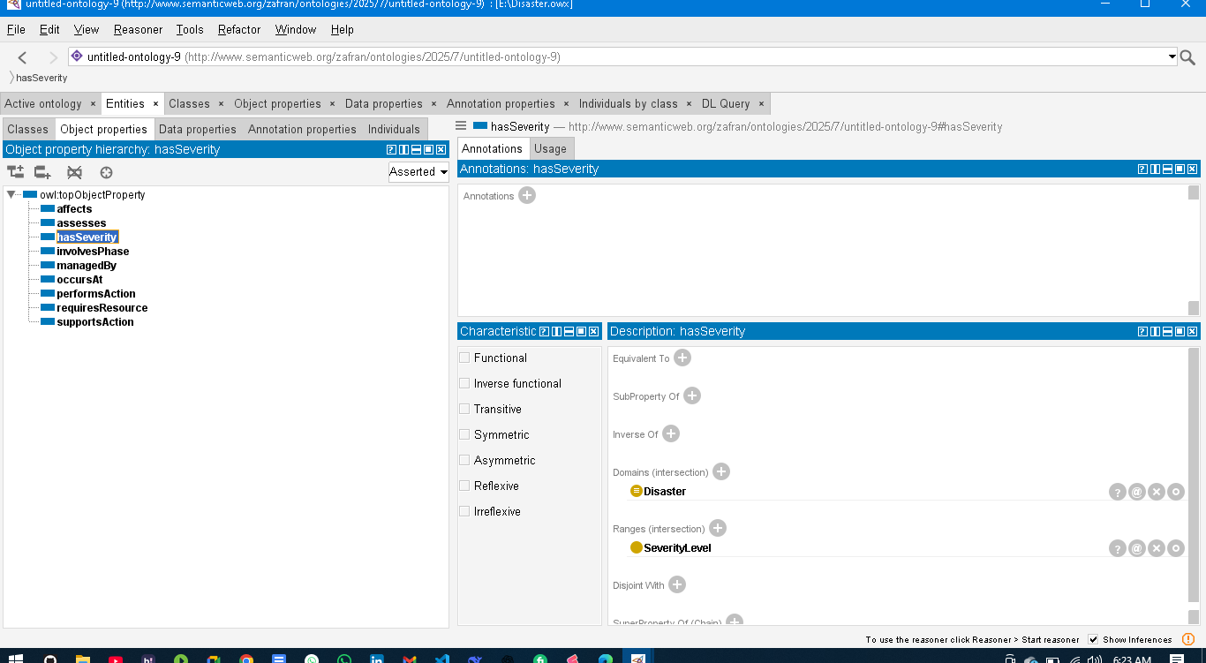
Figure 2: illustrates the object properties

Step 6: Define aspects (Constraints) Logical regulations were added using OWL constructs to enhance reasoning skills [8]. for example, cardinality constraints are used to enforce rules such as a ReliefTeam being assigned to exactly one zone at a time. Datatype constraints ensure the best format for geographical coordinates, timestamps, and aid portions. moreover, conditional axioms were applied, such as: "If a aid has a status of 'deployed', it must be related to a task," thereby enhancing inferencing accuracy and ontology validation [5].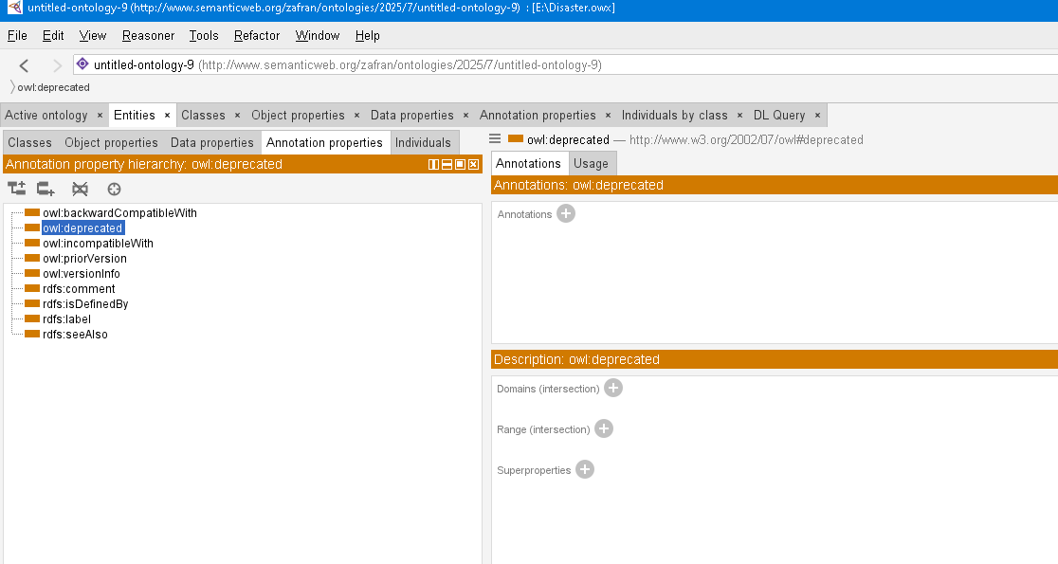
Figure 3: illustrates the OWL restrictions (e.g., deprecated, campatibility)

Step 7: Create times (people) finally, person times representing real-world data were instantiated to test and validate the ontology. This includes growing times of unique failures, affected places, available assets, and response teams, allowing for dynamic reasoning over stay disaster scenarios. The instantiation step transforms the summary model into a usable know-how base that may power wise DMS packages [3]. by following this based method, the evolved ontology not only models disaster control operations correctly but also allows semantic interoperability, automated reasoning, and scalable reuse across unique disaster contexts [4].
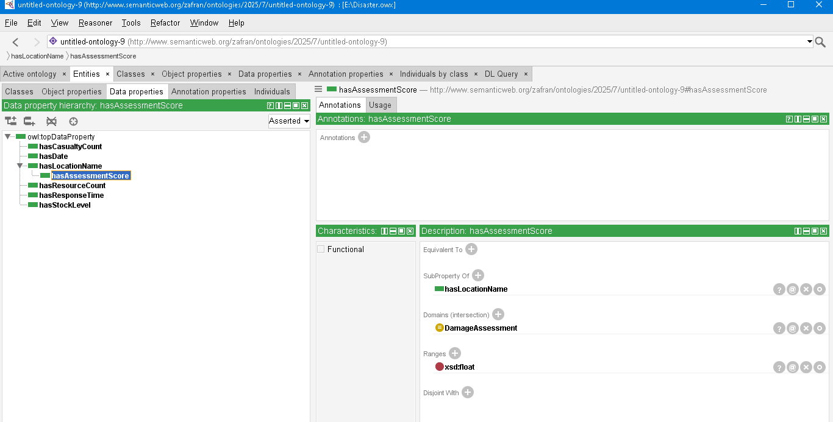
Figure 4: illustrates the Data Properties by class hierarchy

Some Common Mistakes

In documenting the ontology improvement for a disaster management system (DMS), suitable medical style and clarity of language were maintained during the file. the following key practices were adhered to for grammatical accuracy and expert consistency: The word "data" is handled as a plural noun (e.g., "The situational data were obtained from multiple assets"), that's mainly relevant when regarding harm reviews, populace data, or aid inventories in disaster databases. medical constants and logos, although less common on this area, are written using correct formatting when discussing aspects like the Richter scale for earthquakes or wind speeds in hurricanes. Punctuation is used correctly with citation marks. for example, "HighPriority" and "UrbanSearchAndRescue" are used as ontology class names,

with punctuation acting outside the fees until a whole word is being quoted. Inset charts (not "inserts") are referenced correctly when visualizing data such as evacuation timelines or aid deployment maps. The term "rather" is favored over "alternately" when outlining unique response techniques (e.g., "Evacuees can be transported by air; rather, floor transportation can be used for shorter distances"). The word "basically" is averted for approximations or effectiveness, as it lacks precision. rather, quantifiable descriptions are used (e.g., "The DMS gives about 95% accuracy in tracking aid places in real-time"). name formatting follows a steady style: for example, in the name "a Ontology-based method for disaster response control," prepositions like "for" and articles like "a" aren't capitalized until they're the first word. Homophones are used correctly: for example, a disaster can "affect" (verb) a populace, and the "impact" (noun) is big harm. further, "discrete" data points talk to person pieces of data, not "discreet". The difference among "mean" and "infer" is maintained. for example, styles in data may "mean" a expanded risk of landslides, while a disaster manager "infers" the want to issue a warning. Compound words with the prefix "non" are joined without a hyphen until clarity requires it (e.g., noncombatant, noncritical infrastructure). The Latin abbreviation "et al." is formatted correctly with no length after "et" (e.g., "as proposed by Chen et al. of their study on disaster ontologies"). Abbreviations such as "i.e." (that is) and "e.g." (for example) are observed by a comma, adhering to standard academic writing conventions.

Evaluation

On this section, the advanced ontology for the disaster management system (DMS) is evaluated using inference reasoning and querying techniques to validate its shape and retrieve meaningful data [3]. Ontology evaluation is a vital step to ensure that the semantic model is logically sound, operationally correct, and able to helping real-world choice-making tactics in a disaster putting. The primary stage of evaluation focuses on the logical consistency of the ontology using trendy OWL reasoners such as HermiT or Pellet, that are included with the Protégé ontology editor [6]. these reasoners routinely classify the ontology by checking that all defined classes, relationships, and assets regulations do not contradict each other. They verify that all axioms, such as disjoint classes or area and range constraints, align with OWL semantics and do not result in unsatisfiable classes or faulty hierarchies [8]. for example, the reasoner will discover logical flaws like classifying a aid as each 'available' and 'deployed' concurrently if these are defined as disjoint states, or using wrong data sorts for unique homes like area coordinates. moreover, reasoning allows the ontology to infer new data by deriving relationships that aren't explicitly said but logically follow from the present shape [5]. for example, if a ReliefTeam is a subclass of HumanResource, and HumanResource is assigned to a task, the reasoner can infer that a ReliefTeam can be assigned to a task, even if this was not explicitly modeled. This form of inference helps more expressive and wise know-how illustration, that's vital in the dynamic environment of a disaster [4]. moreover, the taxonomy is subtle via the right use of subclass hierarchies. classes such as MedicalTeam and SearchAndRescueTeam are semantically modeled as subclasses of EmergencyResponder, allowing for hierarchical type and contextual grouping. This hierarchical shape allows the DMS to use rules and operations to whole classes of responders or assets without manually specifying each person example, thereby enhancing automation and flexibility. After verifying logical soundness via reasoning, the next stage of evaluation entails SPARQL querying, which exams whether the ontology can aid area-unique data retrieval in real operational scenarios [5]. SPARQL, the query language for RDF-based ontologies, allows users to retrieve exact and unique data from the semantic model. via a chain of competency questions, the gadget’s responsiveness to real-world queries is classed. Examples include: "Which hospitals with available beds are placed inside a 20-mile radius of the earthquake's epicenter?", "Which seek and rescue teams have know-how in collapsed shape rescue?", and "what's the full range of displaced folks in each exact refuge?" Such queries examine the ontology’s ability to aid vital disaster response sports such as medical triage, aid deployment, and situational reporting [7]. This stage also confirms that the item and data homes—such as isLocatedIn, hasSkill, hasCapacity, and hasStatus—are well defined, correctly related to the relevant classes, and yield correct effects when queried [6]. The querying phase further validates whether the relationships encoded in the ontology are bidirectional where wished, and whether regulations (e.g., cardinality constraints on aid allocation) are enforced correctly. for example, querying for all unassigned MedicalTeams ensures that the gadget correctly handles the fame of assets. moreover, queries can simulate dynamic use cases such as tracking the progress of evacuation efforts or identifying gaps in aid distribution, ensuring that the ontology is strong and able to managing the evolving needs of a disaster scenario. together, reasoning and querying not only verify the structural and logical integrity of the ontology but also show its sensible utility in helping wise disaster operations. these techniques ensure that the ontology aligns with the necessities of the disaster control area, helps data interoperability among various response groups, and may evolve with future system needs [4].

Conclusions
The disaster management system (DMS) designed and applied on this report gives a complete and based method to managing disaster-related information via ontology-based modeling. The gadget not only enhances the efficiency of disaster response operations but also ensures semantic consistency, ease of data integration, and wise reasoning [2]. via using gear like Protégé, the ontology truly defined classes such as disaster, aid, agency, and their homes, enabling a system-comprehensible format for vital disaster data [6]. the mixing of reasoning skills allowed for the automated inference of know-how, thereby revealing hidden relationships and validating the ontology's logical shape [4]. moreover, SPARQL queries tested how users can extract meaningful insights from the ontology, helping real-time choice-making and green aid allocation [5]. by keeping compliance with W3C standards and leveraging Semantic net technology, the gadget helps scalability and future integration with rising technology like the net of things (IoT) and AI-pushed predictive analytics for disaster risk discount [8]. In end, this ontology-pushed disaster control gadget gives a sturdy technological basis for wise, scalable, and automatic disaster response and healing operations. it is poised to function a vital issue in modern public safety and emergency control ecosystems, contributing to improved situational focus, real-time coordination, and ultimately, the safety of lives and assets [7].

Appendix
Code:

References
- T. R. Gruber, “A translation approach to portable ontology specifications,” Knowledge Acquisition, vol. 5, no. 2, pp. 199–220, 1993.
- M. Uschold and M. Gruninger, “Ontologies: Principles, methods and applications,” The Knowledge Engineering Review, vol. 11, no. 2, pp. 93–136, 1996.
- N. F. Noy and D. L. McGuinness, “Ontology Development 101: A Guide to Creating Your First Ontology,” Stanford University, Technical Report KSL-01-05, 2001. [Online]. Available: https://protege.stanford.edu/publications/ontology_development/ontology101.pdf
- T. Berners-Lee, J. Hendler, and O. Lassila, “The Semantic Web,” Scientific American, vol. 284, no. 5, pp. 34–43, 2001.
- G. Antoniou and F. van Harmelen, A Semantic Web Primer, 2nd ed. MIT Press, 2008.
- M. Horridge, S. Bechhofer, and N. Drummond, “A practical guide to building OWL ontologies using Protégé 4 and CO-ODE tools,” University of Manchester, 2009. [Online]. Available: http://owl.cs.manchester.ac.uk/tutorials/protegeowltutorial/
- F. F. Li, H. C. Kim, and S. C. Kim, “A disaster management ontology for shared situational awareness,” in 2011 7th International Conference on Next Generation Web Services Practices, 2011, pp. 384–389.
- W3C OWL Working Group, “OWL 2 Web Ontology Language Document Overview (Second Edition),” W3C Recommendation, Dec. 2012. [Online]. Available: https://www.w3.org/TR/owl2-overview/

IEEE conference templates contain guidance text for composing and formatting conference papers. Please ensure that all template text is removed from your conference paper prior to submission to the conference. Failure to remove template text from your paper may result in your paper not being published

